|  |  |
| --- | --- |
| LINE FOllowing Robot | Abstract  A line following Robot is basically an autonomous robot which follows a strip of black line without any input from the user. The robot consists of various components such as: IR sensors, microcontroller, motor driver, and motors, etc. Line follower Robot is one of the first robots that beginners and students would get their first robotic experience with.  Devesh Sonker |

INTRODUCTION

A line follower robot is an autonomous robot that has a microcontroller which takes decisions for the movements the robot makes. The robot basically follows a strip of line and moves along the line as it moves forwards. The robot uses several IR sensors to identify the line thus assisting the robot to stay on the track. Usually, the visual line is the path in which the line follower robot goes and it will be a black line on a white surface but the other way (white line on a black surface) is also possible. Robot must be able to detect particular line and keep following it.

Input: Read the white/black on the floor and condition the input signal(s) for transmission into the microcontroller in a way that questions can be asked and decisions made.

Process: Based on the inputs received, microcontroller decide what change (if any) needs to be made to the robots speed and direction. Convert the results of any decisions made into something that can be sent to motor speed control and/or steering.

Output: Send the old or the newly adjusted control signals to speed and/or steering devices.

If the sensor detects the black line in the centre, it keeps on moving forward. If the black line is detected by the left sensor, the robot takes a left until it finds the black line in the centre, and the same procedure takes place when the right sensor detects the line.

Line follower Robot is one of the first robots that beginners and students would get their first robotic experience with and often find it intriguing and helps them build their interest in Robotics and Electronics.

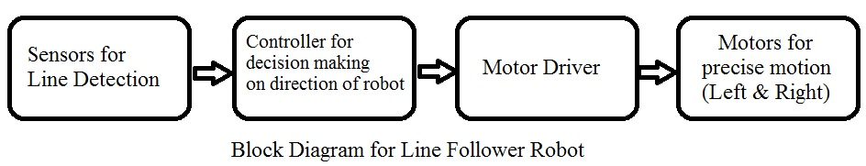

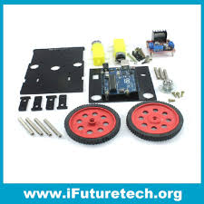COMPONENTS:

1. Arduino UNO/Nano/Pro Mini
2. IR Sensors
3. L298D Motor Driver
4. DC motors
5. Chassis and Wheels
6. Castor Wheel
7. Power Supply

**Arduino UNO** is a microcontroller board which consists of a microprocessor-ATmega32p, oscillators, resistors, capacitors, serial communication i.e. FTDI chip, power regulation circuits and an inbuilt LED. The microcontroller takes the input from the sensors processes the input according to the program provide to it and presents an output for the same.

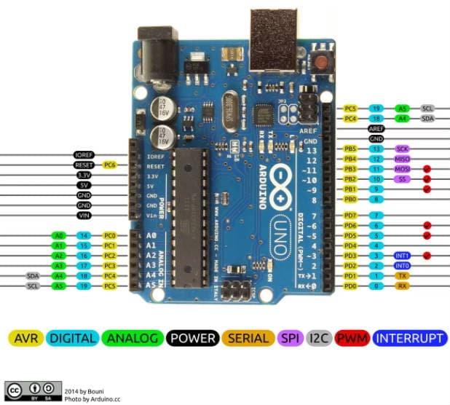

**Motor Driver** L293D Motor Driver IC is an H bridge IC which drives the output with the help of four MOSFET gates with respect to the inputs. It helps to drive the motors in both the directions without altering the polarity of the inputs.

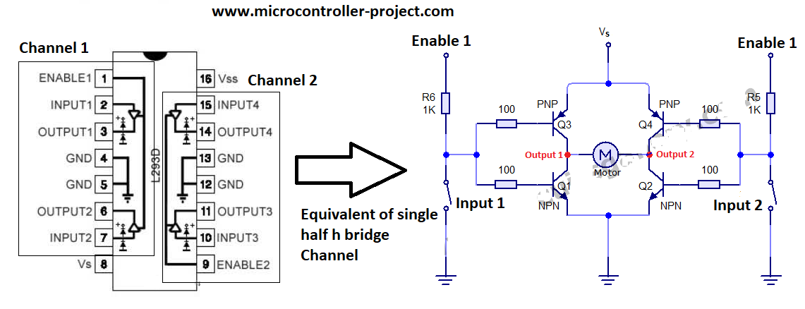

**IR reflectance sensors** contain a matched infrared transmitter and infrared receiver pair. These devices work by measuring the amount of light that is reflected into the receiver. Because the receiver also responds to ambient light, the device works best when well shielded from ambient light, and when the distance between the sensor and the reflective surface is small (less than 5mm). IR reflectance sensors are often used to detect white and black surfaces. White surfaces generally reflect well, but while black surfaces reflect poorly.

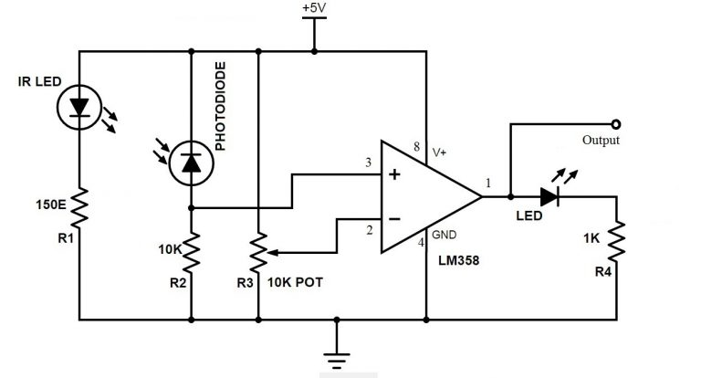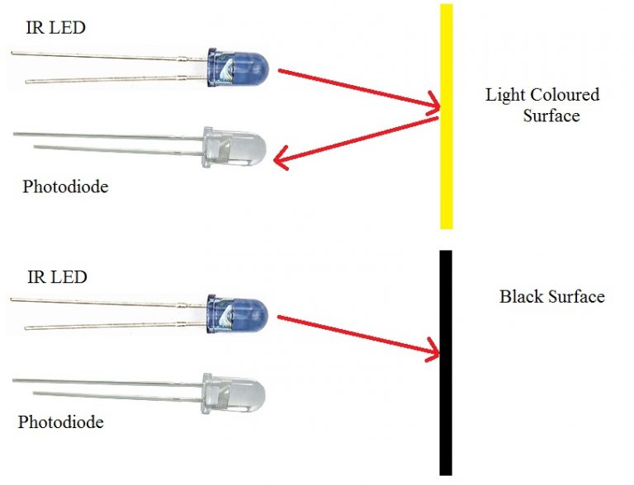

**DC Motors:** The DC motors are controlled through analogous values which are produced by the analogous pins of the microcontroller or by simply providing them with logic High or Low. Geared motors can also be used to reduce/increase the speed, torque ratio of the motor.

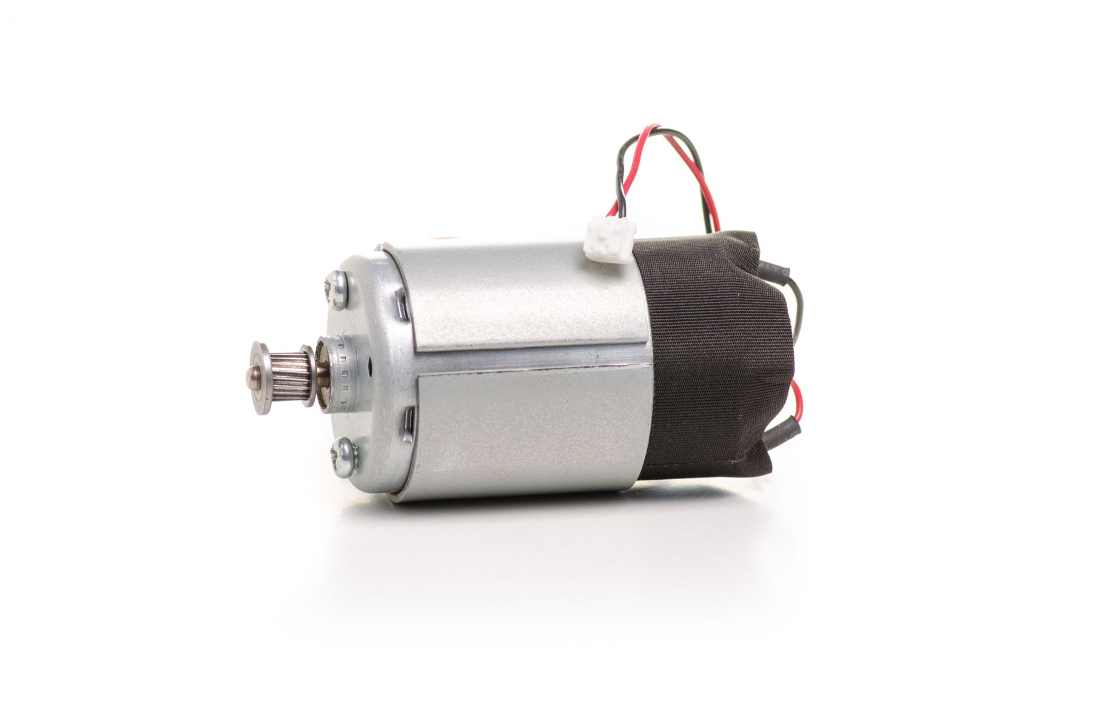

**Power Supply:** A power supply has to be provided in order to drive the motors as well as power up the sensors and the microcontroller. It can be done by providing with a battery or a dc supply through an adapter.

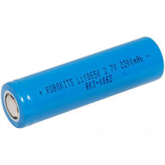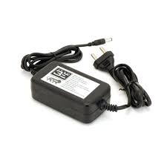

IMPLEMENTATION

The line following robot is one of the self-operating robots. That detects and follows a line drawn on the area. The line is indicated by white line on a black surface or black line on a white surface. This system must be able to follow the line. This application depends upon the sensors.

Here we are using five sensors as an array for path detection purpose. That is proximity sensor and IR sensor. The proximity sensor used for path detection and IR sensor used for obstacle detection. These sensors are mounted at the front end of the robot. The robot takes the input of the sensors and calculates the error and then starts to move.

The error is calculated on the basis of where the sensors provide the logic High for the black line they detect, the error is further classified as positive or negative for the directions i.e. left or right.

An array stores the data from the sensors sequentially and calculates the error in accordance. Whenever the sensor detects a black surface it updates the array with a ‘1’ value in the sensors location.

Error = 0

Error = -1

Error = 1

|  |  |  |  |  |
| --- | --- | --- | --- | --- |
|  |  |  |  |  |
|  |  |  |  |  |
|  |  |  |  |  |

Based on the error the robot calculates a PID value based on the error and writes it to the motors as an analogous value. A proportional–integral–derivative *controller* (*PID controller* or three-term *controller*) is a *control* loop mechanism employing feedback that is widely used in industrial *control* systems and a variety of other applications requiring continuously modulated *control*.

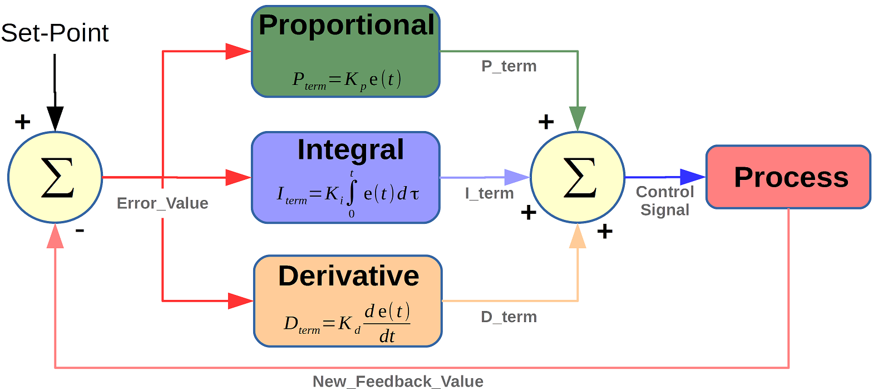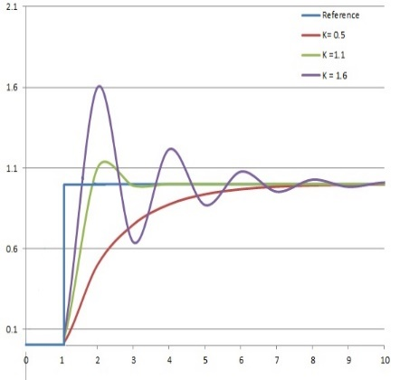

The PID constants are defined in the beginning of the program, these can be changed in accordance of how the robot behaves while following the line.

The DC motors are provided with analogous signals which control the speed and direction of each motor individually and constrained to their maximum value i.e. 8-bit for Arduino UNO/nana/Pro-mini, the value can be mapped between 0 – 255.

These values keep on altering with each loop of the program, where the sensor values are updated in the array, and a new error is calculated and provided to the PID function, and this process continues until the sensors read all values as either ‘0’ or ‘1’, when this condition appears the robot stops, if the array is zeros the robot stops and turns left until it finds some change in the array values.

The sensors are placed with the minimum distance between the surface and them. This ensures the minimum delay in providing inputs to the processor.

The rechargeable battery is connected to the motor driver which requires higher potential as compared to the microcontroller and sensors, the battery voltage is first regulated and then fed to the low potential devices.

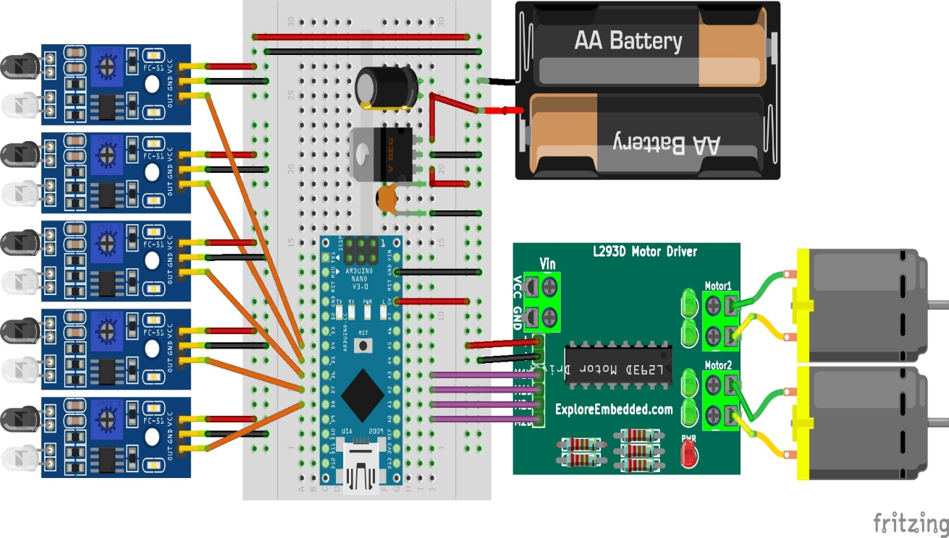A schematic has been shown below for your reference.

The motor driver requires both the higher potential as well as the lower potential to drive the motors and power up the L293D IC.

